The Title Should Be in Title Case, Bold 14-point, with a Maximum of 25 Words

First Author¹, Second Author^{2,*} and Third Author^{,3}

¹Affiliation of the first author, Department/Institution, City, State/Province, Country
²Affiliation of the second author, Department/Institution, City, State/Province, Country
³Affiliation of the third author, Department/Institution, City, State/Province, Country
* Corresponding author: SAuthor@xyz.edu

The submission should be a condensed version of your presentation and include all significant findings. Write the text so that readers who are not specialists can appreciate the purpose of the study and understand the procedures and conclusions. The text, entirely written in English, should include a brief introduction and motivation of the study, including experimental procedures, main results, and conclusions. It is not necessary to divide the text into sub-sections, except for the References section.
Your submission must be a Microsoft Word file in .doc or .docx formats. The body of the text (i.e., excluding title, authors, affiliations, references, and figure captions) should be between 100-750 words. Limit abstract text and figures to 1-page. A maximum of two figures may appear in your submission. Figures are NOT required for regular submissions, but submissions applying for a Meeting Award should have at least 1 figure. Include figure labels and scale markers on all figures. Artwork and tables must be electronically inserted into the document. Check that the line widths and font sizes allow the figure to be clear at its final size. If included, references may be listed at the end of the text, using appropriate reference styles.[1]
All submissions are reviewed by the Program Committee according to the following criteria: (a) relevance to a specific symposium, (b) scientific content, quality and innovative proposals, (c) clarity of the text, and (d) compliance with the format. To be considered for meeting awards, all submissions must meet these requirements. All accepted papers must be presented by a meeting registrant. If the registrant cannot attend due to unforeseen circumstances, an alternate presenter should be arranged by the submitter or original presenter.

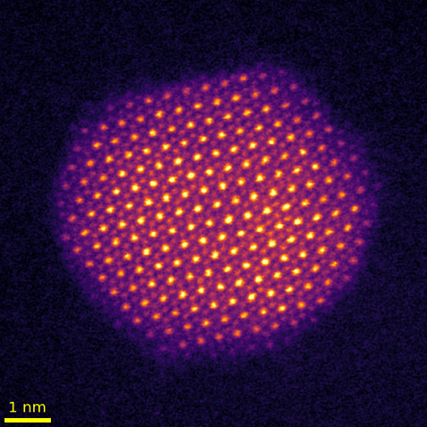
Fig. 1. Provide a short description of the figure, including labels and scale markers as appropriate.

References:

1. Author FM and Author S. Journal (year) volume page-numbers. https://doi.org/10.000

